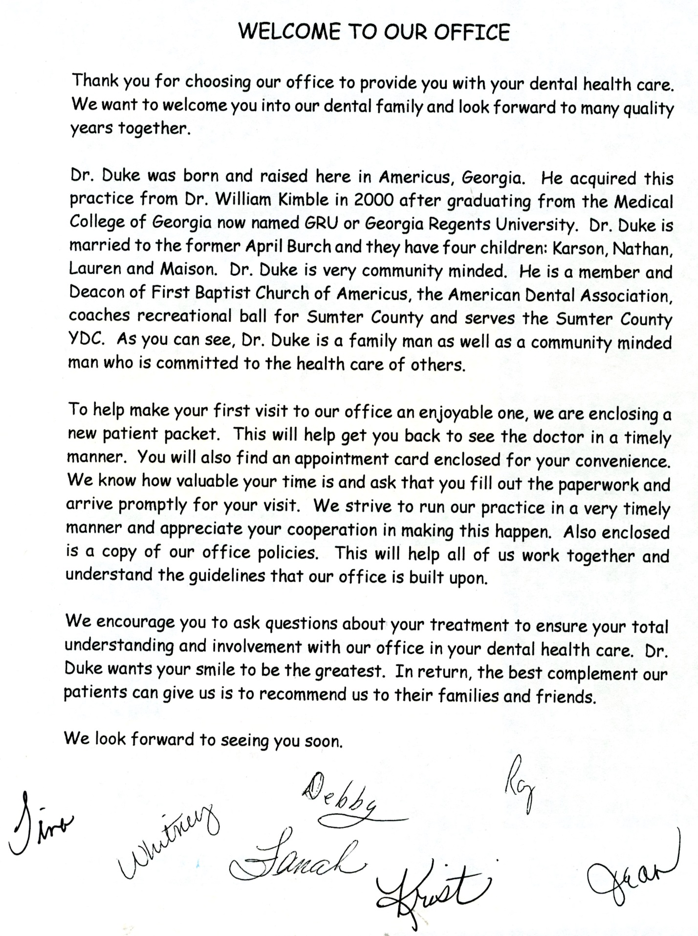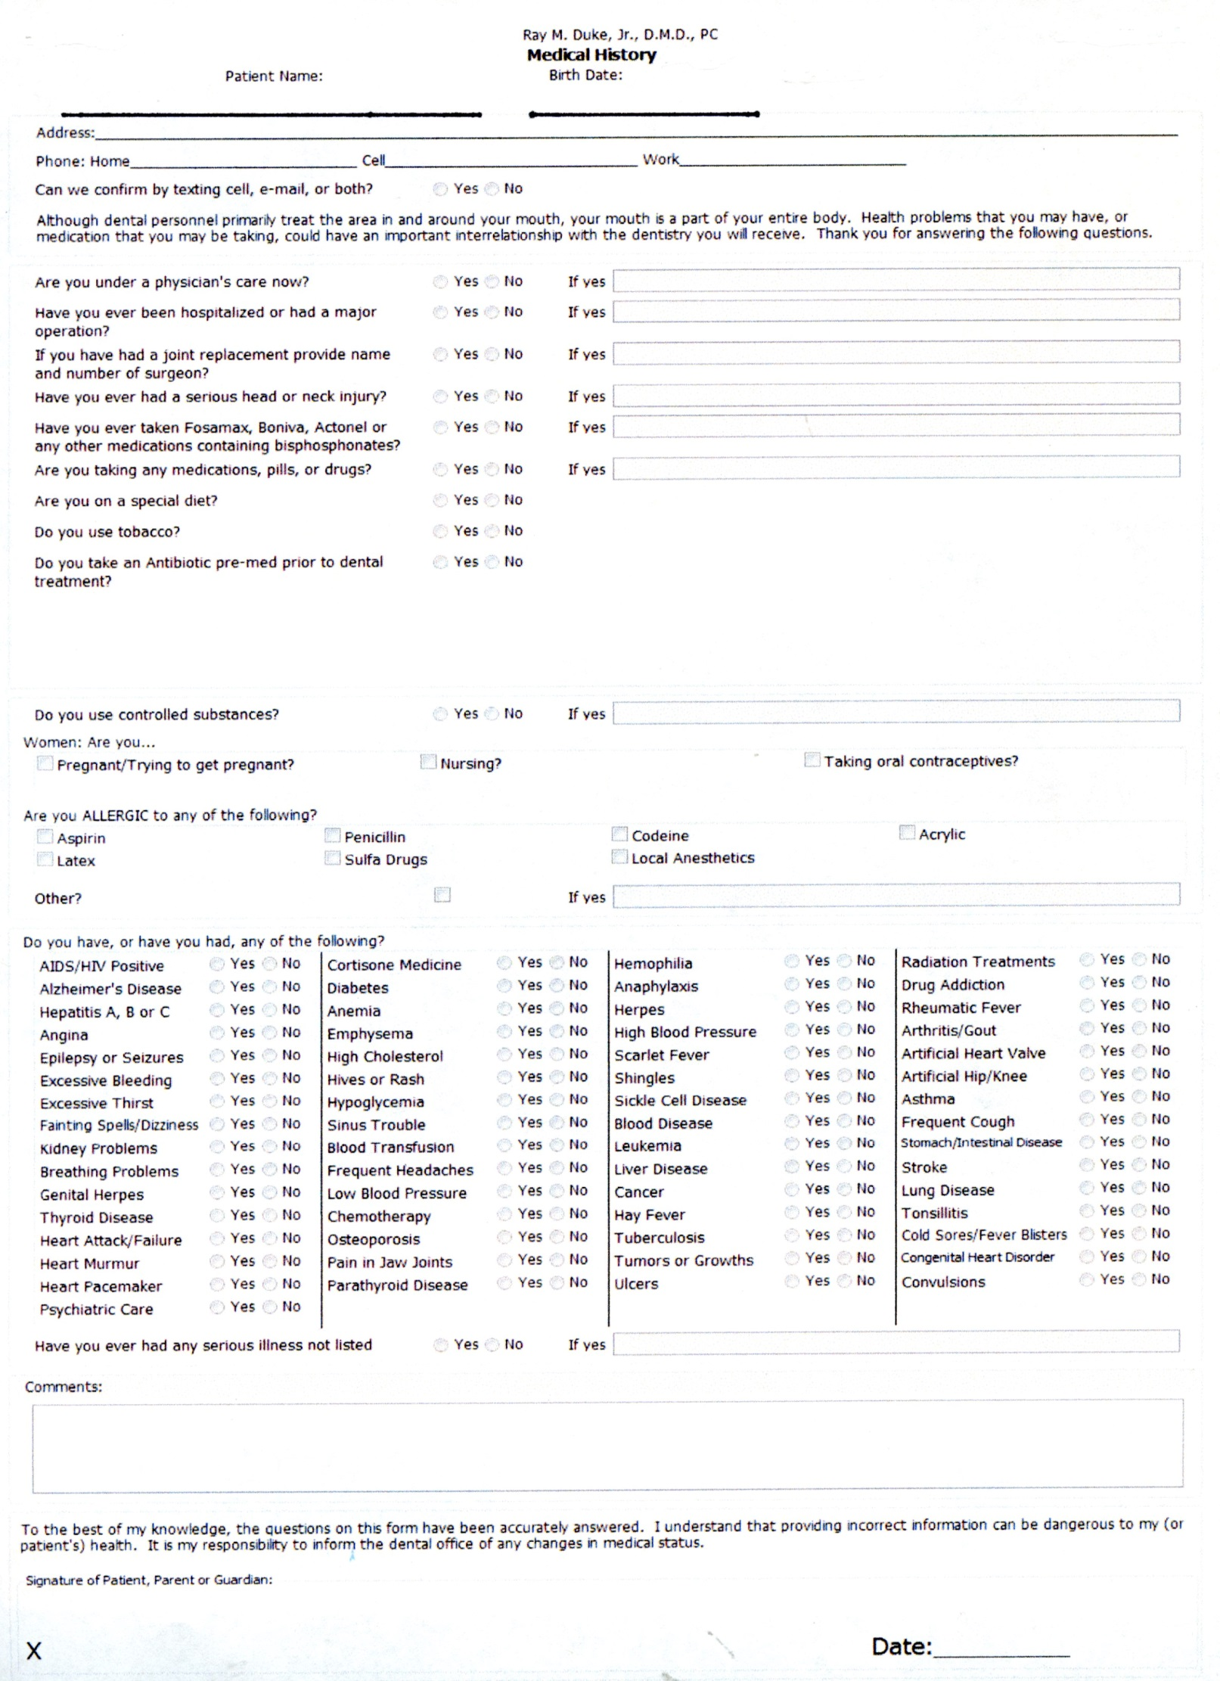

RAY M. DUKE, JR, DMD, PC
626 East Forsyth Street, Americus, Georgia 31709
Patient Registration
Patient Information:
First Name:______________________________ Last Name:______________________________________ Preferred Name:__________________________
Street Address:____________________________________________ City/State/Zip_____________________________________________________________
Home Phone:_______________________________ Work phone:______________________________ Cell Phone:___________________________
Email Address:______________________________________________________ May we text you? ( )YES ( )NO
Preferred Contact (please check): ( ) Home ( ) Work ( ) Cell ( ) Email
Sex (circle): Male Female Marital Status (circle) if adult: Single Married Divorced Widowed
Date of Birth:__________________________________ Social Security Number:_____________________________
Preferred Pharmacy:___________________________________ ER Contact: Name:____________________________________ Phone:_________________
Phone:________________________________ Relationship to Patient:________________________________________________
Place of Employment:__________________________________________________________________________________________________________________________
Responsible Party: or SAME AS ABOVE (circle if same as above)
First Name:______________________________ Last Name:____________________________________ Preferred Name:__________________________
Street Address:____________________________________________ City/State/Zip___________________________________________________________
Home Phone:_______________________________ Work phone:______________________________ Cell Phone:___________________________
Email Address:______________________________________________________ May we text you? ( )YES ( )NO
Preferred Contact (please check): ( ) Home ( ) Work ( ) Cell ( ) Email
Sex (circle): Male Female Marital Status (circle)if adult: Single Married Divorced Widowed
Date of Birth:__________________________________ Social Security Number:_____________________________
Place of Employment:__________________________________________________________________________________________________________

Primary Insurance Information:
Name of Insured___________________________________________ Relationship to Insured: Self Spouse Child Other
Insured SSN:_______________________________________________ Insured DOB:_________________________________________________
Employer:__________________________________________________ Insured Company:___________________________________________
Address:____________________________________________________ Address:______________________________________________________
City/State/Zip:_____________________________________________ City/State/Zip:_______________________________________________
Secondary Insurance Information:
Name of Insured___________________________________________ Relationship to Insured: Self Spouse Child Other
Insured SSN:_______________________________________________ Insured DOB:_________________________________________________
Employer:__________________________________________________ Insured Company:___________________________________________
Address:____________________________________________________ Address:______________________________________________________
City/State/Zip:_____________________________________________ City/State/Zip:_______________________________________________

Whom may we thank for referring you or how did you hear about us?__________________________________________________________________
RAY M. DUKE, JR, DMD PC
626 East Forsyth Street, Americus, Georgia 31709
ACKNOWLEDGEMENT OF RECEIPT OF
NOTICE OF PRIVACY PRACTICES

I, _________________________________________________________, have received a copy of this office’s NOTICE OF PRIVACY PRACTICES.

________________________________________________________________
Please Print Name

_________________________________________________________________
Signature

_________________________________________________________________
Date
FOR OFFICE USE ONLY
We attempted to obtain written acknowledgement of receipt of our Notice of Privacy Practices, but acknowledgement could not be obtained because:
- Individual refused to sign
- Communications barriers prohibited obtaining the acknowledgement
- An emergency situation prevented us from obtaining acknowledgement
- Other (Please Specify)

___________________________________________________________________________________

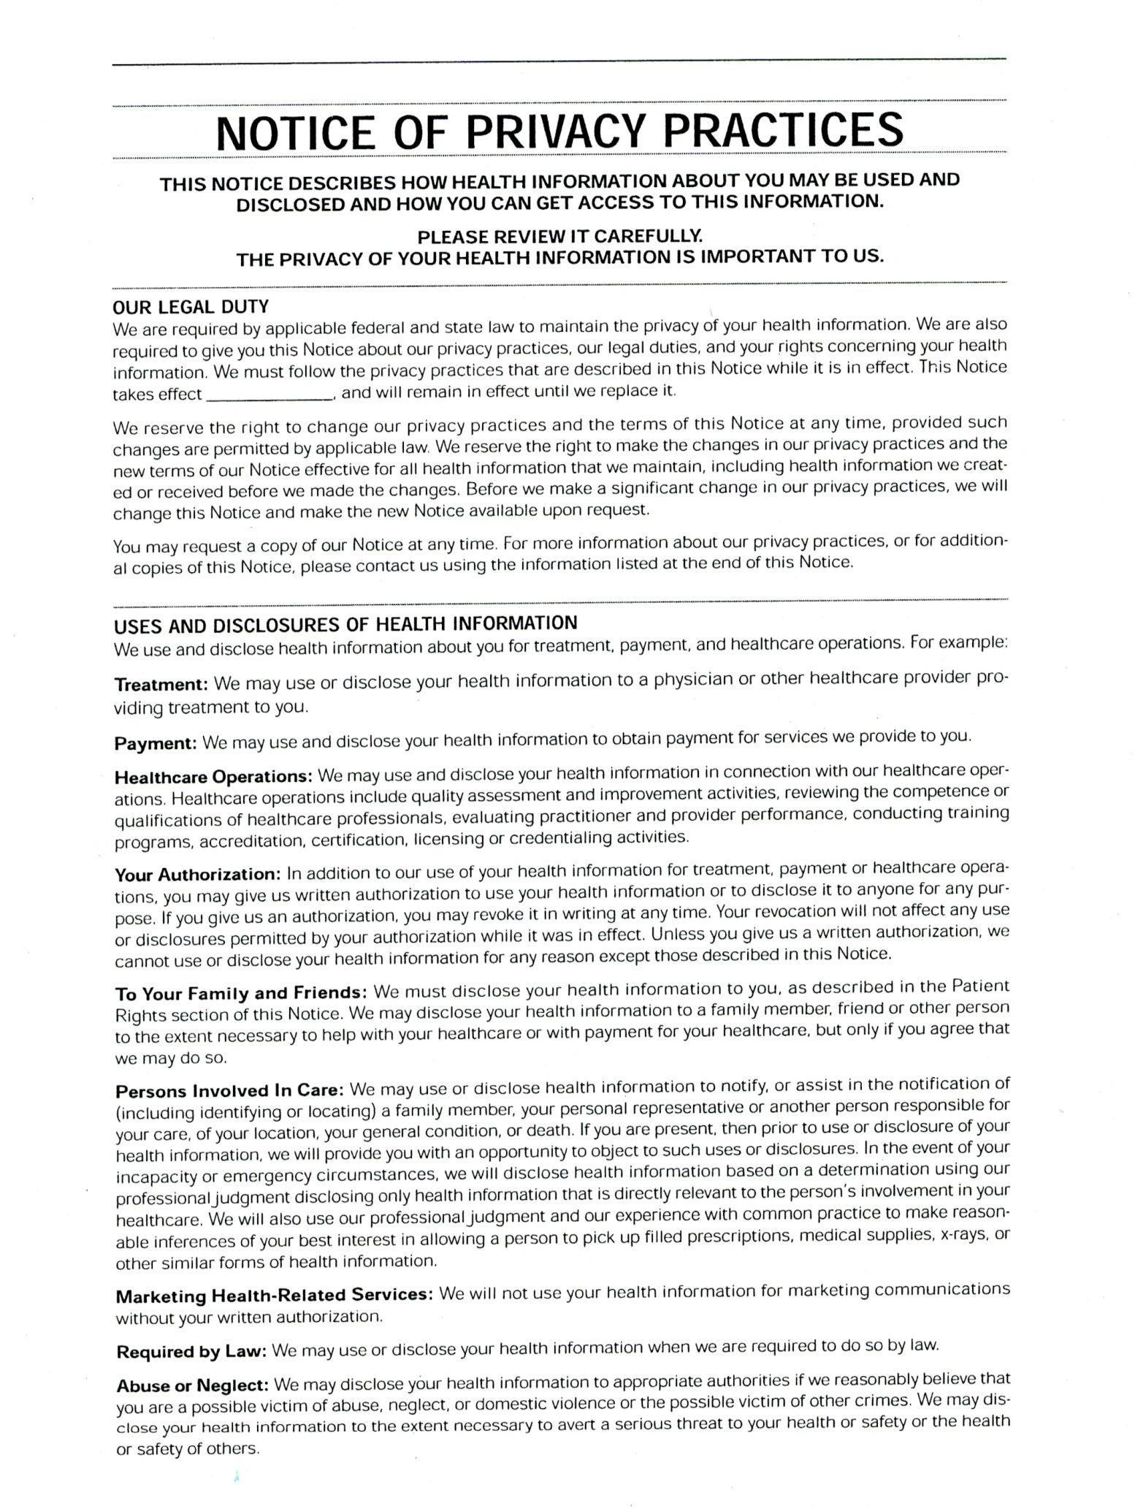

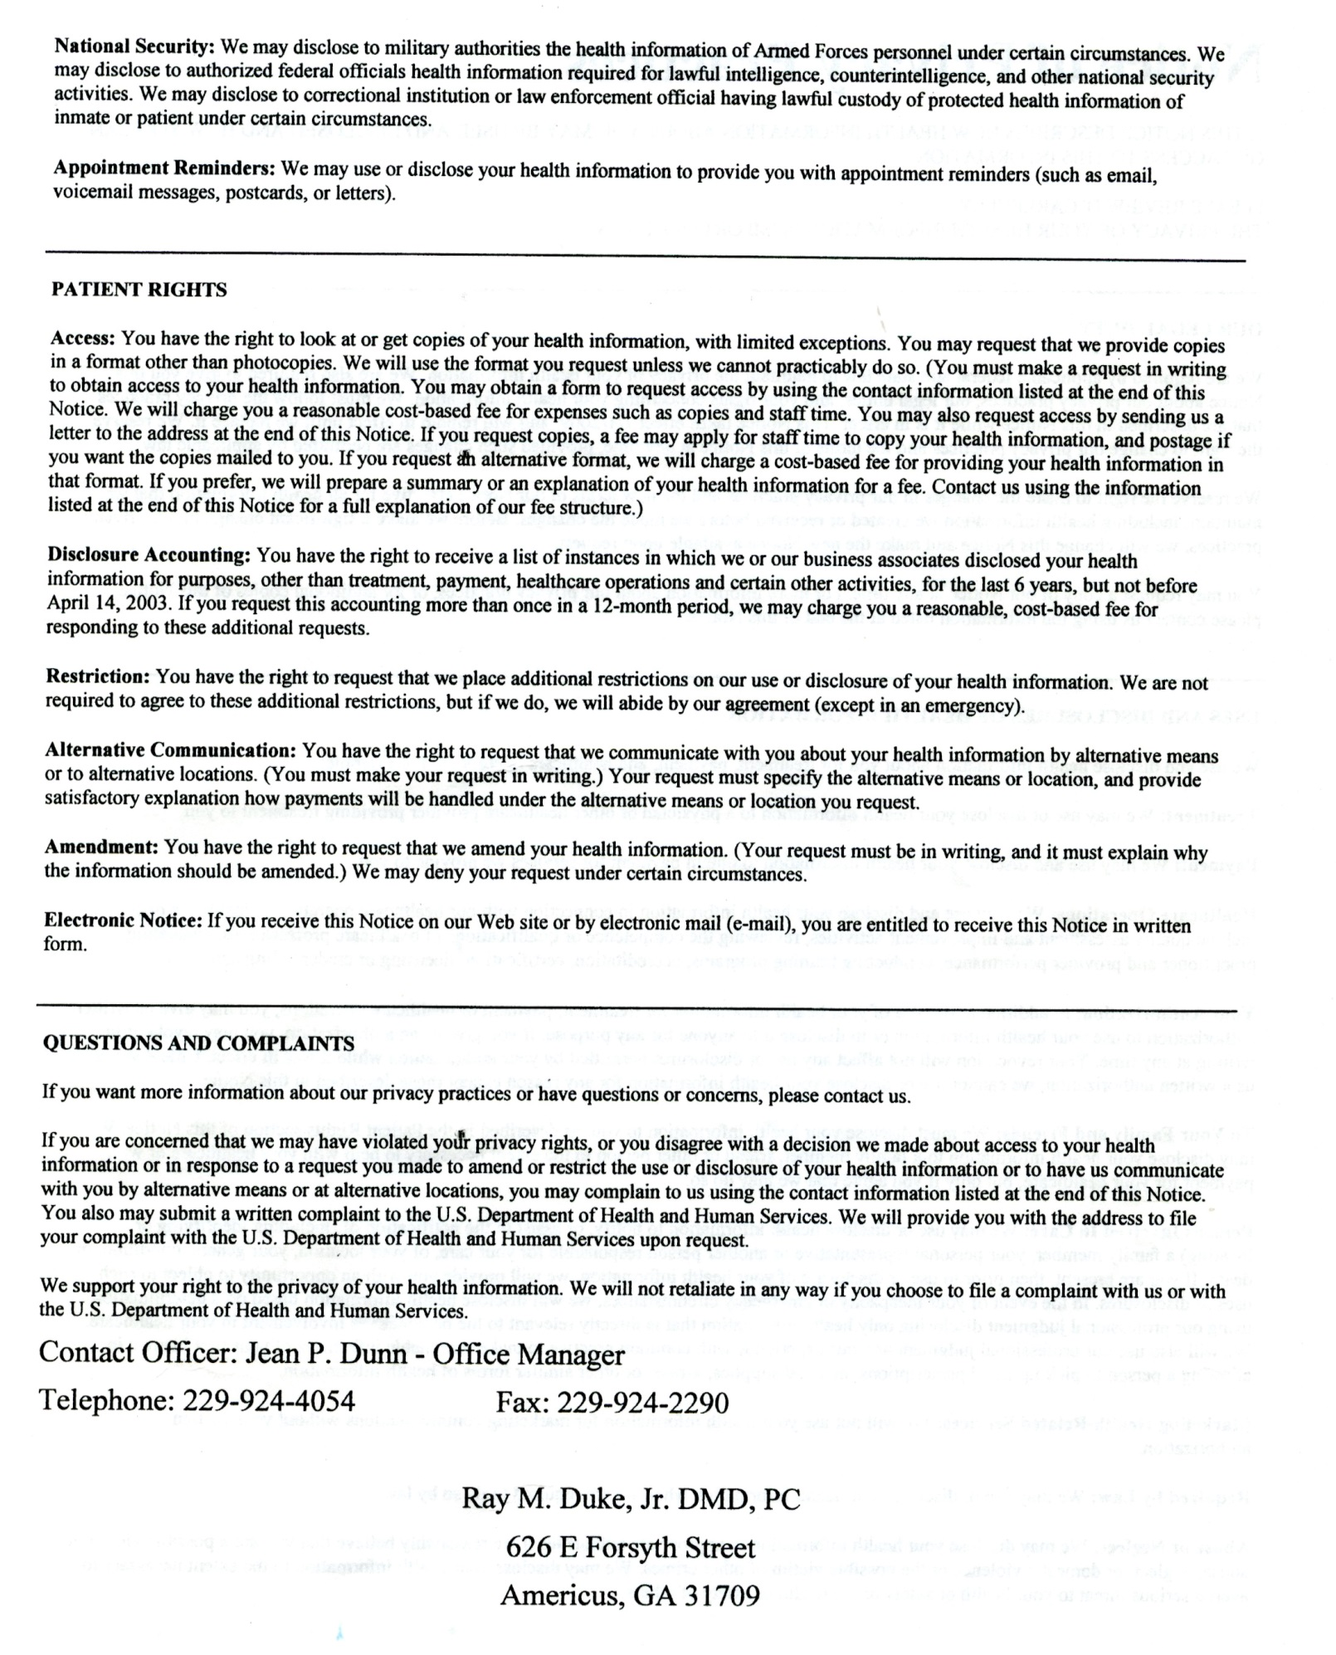

RAY M. DUKE, JR, DMD, PC

GENERAL CONSENT FORM

CONSENT TO TREATMENT

I do hereby authorize and request the performance of dental services and the use of whatever procedures Dr. Duke May deem necessary for treatment. I understand that Dr. Duke and his staff will use clinical and patient management techniques that are reasonable, necessary, and advisable. I also authorize the administration of anesthetics or analgesics that may be deemed appropriate by Dr. Duke. I understand that the purpose for using local anesthetics may be therapeutic, diagnostic, or for the treatment of facial pain. I understand that potential complications include, but are not limited to pain, swelling, bruising, temporary limited opening, and local infection. I understand that in occasional cases the anesthesia may be prolonged and in very rare cases permanent.

I understand that I am responsible for obtaining any current x-rays that may have been taken at a previous office. If I do not obtain them, I permit the retaking of any necessary x-rays at my expense.

I understand that any treatment plans presented, along with the fees outlined, could change depending on the time elapsed since the initial examination and extent of dental pathology. Occasionally, once the treatment plan has been started, complications may arise that dictate additional procedures or treatment. Dr. Duke or his staff will always advise me of any changes.

In the event that Dr. Duke or a staff member is exposed to my blood or other bodily fluids, I agree to have my blood drawn and tested for Hepatitis B virus (HBV), Hepatitis C virus (HCV), and the human immunodeficiency virus (HIV). I understand that this testing would be done in a confidential manner, and would be made available only to the person who was exposed, and the person would be advised of his/her rights regarding protected health information.

Patient/Guardian signature Date
YOU ARE ENTITLED TO A COPY OF THIS CONSENT AFTER YOU SIGN IT

Ray M. Duke, Jr. DMD, PC
Welcome To Our Practice

We are committed to helping you keep your beautiful smile and to creating a long lasting positive relationship with you and your entire family. It is our goal to provide the highest quality of dental care to each patient. Our greatest compliment is when you recommend us to your family and friends. We appreciate the opportunity of serving you and your entire family.

OFFICE HOURS AND APPOINTMENTS

Our office hours are Monday - Thursday 8:30 am until 5:30 pm.

Patients are seen by appointment only due to forty percent of our patients being school age, you will alternate morning and afternoon appointments to enable everyone the opportunity to only miss one class per year out of school. Two weeks before your six months checkup, you will be mailed a post card to remind you. At that time if your appointment is inconvenient, please call our office to reschedule as there is a $30 failed appointment fee that will be required before rescheduling. If you have text, you will receive a text one week prior of your appointment after scheduling to remind you of your appointment, receive text one day prior to your appointment and/or receive a phone call the day before your appointment. If you are a cash basis, insurance basis or Medicaid patient and fail to keep your appointment without notifying us 24 hours in advance, you will be charged the $30 fee and it must be paid before rescheduling the failed appointment. If you have Wellcare, PeachState or Amerigroup, per their regulations on the third failed appointment, you will be dismissed from the practice. No-Shows are unacceptable as failure to keep an appointment not only compromises your health but inconveniences others. If you cannot keep an appointment, please call a minimum of 24 hours in advance of your appointment to reschedule.

With today’s technology, may we suggest that you put your appointment in your phone to remind you of your appointment or maybe you have some other technology that will remind you along with our 3 contacts.

We pride ourselves on seeing you in a timely manner. Only under emergency situations will you experience any wait time and you will be notified immediately upon sign in as you may prefer to reschedule. We ask that you give us the same respect by being on time. Anyone that is 10 minutes late will be asked to reschedule as this is the only way we can stay on time for all patients including you.

If you do not update your phone numbers/address and we are unable to confirm your appointment, we will cancel your appointment without notice.

Insurance

We file insurance as a courtesy to you. If you have any questions regarding your coverage, please call the 800 number on your insurance card. You will want to ask questions regarding your deductible, calendar year maximum, whether you have a waiting period for major dental work (if your insurance is new or less than a year old), preventive coverage, basic and major coverage. If more than one insurance company is involved, we will file both primary and secondary insurances. It is the responsibility of the subscriber to inform our office of any insurance changes during treatment. If at any time insurance benefits change during treatment, the remaining balance, if any, becomes the responsibility of the patient. Any unpaid balance is your responsibility, whether insurance related or not. This office is not responsible for benefits you feel should have been paid, changes in coverage, etc. You are 100% responsible for 100% of the treatment fee and any additional charges incurred. You will be required to pay your deductible and any percentage balance AT THE TIME TREATMENT OCCURS as we do not bill accounts due to the high cost of collection. All accounts must remain current. Any un-expected balance not covered by insurance is also your responsibility. Also, we will do one pre-authorization per treatment needed at no charge. If you let that pre-authorization expire without proceeding with work, each additional pre-authorization for the same treatment will have a processing fee of $30.00.

Payment/Returned Check Fees/Collections

PAYMENT IS EXPECTED AT THE TIME TREATMENT IS RENDERED. We have two outside payment plans.

One is administered through Care Credit. You may apply with them by phone 800-365-8295 or online by visiting www.carecredit.com. They will check your credit and if approved depending on the amount needed, you will be offered either 6 or 12 months at no interest or 13 months and above with interest.
The other is through I Care Financial. No credit check is required, there is a 15% processing fee, a 30% down payment is required and you will have to have a debit card so that monthly payments will be processed through our office.

There will be a $35 insufficient fund fee charged to any account for any returned check and your returned check is turned over to Quick Recovery.

If your insurance fails to pay, you have a returned check or a balance on your account for any reason that would entail collection; there is a 36% collection fee which will be added to the balance of your account. If your account is turned over to the Magistrate Court, all court costs will be included in the collection procedure.

Parent/Guardian on Site

Patients under the age of 18 (that did not drive themselves to their appointment) must have a parent and/or guardian on site with them. Please do not leave during your child’s appointment under any circumstances. Due to our office being on a busy highway, we request that you wait in our waiting room to ensure the safety of your young child/children in leaving our office as well as any emergency that may arise. If a parent drops a minor child off, we will reschedule the child’s appointment for a later date when a parent or guardian can be present. We do not allow parents to accompany their child into the exam rooms. Your child’s treatment will be discussed with you by the doctor, assistant or hygienist after the appointment. We have found that children will work with us better when you are not present. However, if you child is frightened and will not cooperate, we will not force any treatment on your child. We will immediately come get you and refer to a pediatric dentist until they are more comfortable.

By signing this statement, I declare that I have read and understand the Office Policies for Ray M. Duke, Jr., DMD, PC.

________________________________________ ______________________
Patient/Guardian Date

OFFICE COPY

